CHAPTER FOUR
SYSTEM IMPLEMENTATION AND DOCUMENTATION

4.0 Introduction
This chapter presents the implementation of NaijaTax Enlighten, a cross-platform tax companion application that helps Nigerian individuals and small businesses understand and compute their obligations under the Nigeria Tax Act (NTA) 2025. The chapter first discusses the criteria used in choosing the development environment, then presents the implementation architecture, the program modules, the input/output formats, the information and data flows of the system, and screenshots of the working application. Finally, the procedures used to test the software are presented, followed by the system documentation: the data dictionary, the user manual and a pointer to the source code listing.

4.1 Choice of Development Environment
The choice of platform, tools and programming languages has a direct effect on how easily a project can be completed, maintained and deployed. A wrong choice can derail implementation, while the right one shortens development time. NaijaTax Enlighten has three demands that guided every choice: (i) it must run on Android, iOS and the web from one code base, because the target users access the internet mostly through mobile phones; (ii) it must perform exact financial calculations and protect user data; and (iii) it must be affordable to host as a student project while remaining production-ready.

4.1.1 System Platform
Development was carried out on a Windows 10 Pro (64-bit) laptop with 8 GB RAM. The finished system runs on the platforms summarised in Table 4.1.
Table 4.1: System platform and hardware/software requirements
Component | Platform / Requirement
Development machine | Windows 10 Pro 64-bit, Intel Core processor, 8 GB RAM, 20 GB free disk space
Mobile client | Android 7.0 (API 24) or later; iOS 13 or later
Web client | Any modern browser (Chrome, Safari, Edge, Firefox) on phone or desktop
Application server | Node.js 20 runtime on Render (Linux cloud container)
Database and authentication | PostgreSQL and Supabase Auth on the Supabase cloud platform
Network | Internet connection (HTTPS) for sign-in, calculations and AI features

4.1.2 Integrated Development Environment and Tools
Visual Studio Code was the main IDE, with the Flutter, Dart, ESLint and Prisma extensions providing code completion, debugging and hot reload. The Android SDK (via Android Studio) supplied the emulator and build tools for the APK, and Xcode is required for iOS builds. Git and GitHub were used for version control, while GitHub Actions ran automated checks on every push. draw.io was used to produce the design diagrams in this chapter.

4.1.3 Choice of Programming Languages
Dart with the Flutter framework (version 3.44) was chosen for the client because a single code base compiles to native Android and iOS apps and to a web application, which removed the need to write three separate apps. Flutter's widget system also gave full control over layout across phone, tablet and desktop screen sizes.
TypeScript on Node.js with the Express framework was chosen for the server. TypeScript adds static types to JavaScript, catching errors at compile time, which matters for tax logic where a wrong field type silently produces a wrong amount. Node.js handles many concurrent network requests efficiently, which suits an API that also calls external AI and news services.
PostgreSQL, accessed through the Prisma ORM, was chosen for data storage. PostgreSQL is a reliable relational database with an exact DECIMAL type, so naira amounts are stored without floating-point rounding errors. Prisma generates type-safe queries and versioned migrations from a single schema file. Table 4.2 summarises the main languages, frameworks and libraries used.
Table 4.2: Languages, frameworks and key libraries
Layer | Technology | Purpose
Client | Dart, Flutter 3.44 | Cross-platform user interface (Android, iOS, web)
Client | Riverpod, go_router, Dio | State management, navigation and HTTP requests
Client | Hive, fl_chart, pdf | Local cache, charts and PDF tax reports
Server | TypeScript, Node.js 20, Express | REST API and business logic
Server | Zod, Helmet, express-rate-limit | Input validation and security
Server | Google Gemini / Groq SDKs | AI tax assistant answers
Data | PostgreSQL, Prisma ORM | Relational storage and data access
Auth | Supabase Auth (JWT) | Email, phone OTP and Google sign-in
Testing | Vitest, flutter analyze, GitHub Actions | Unit tests, static analysis, CI

4.2 Implementation Architecture

4.2.1 System Architecture
NaijaTax Enlighten follows a three-tier client–server architecture, shown in Figure 4.1. Each tier can be developed, deployed and scaled independently.
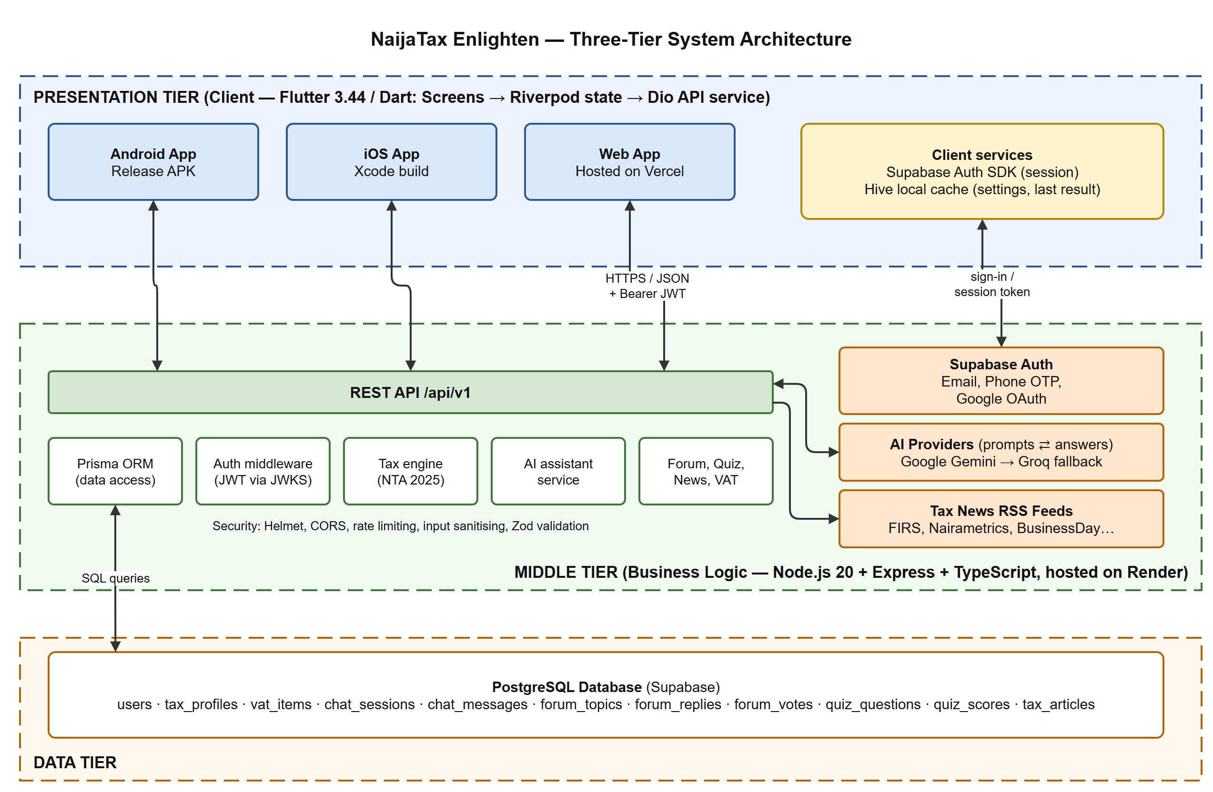
Figure 4.1: Three-tier system architecture of NaijaTax Enlighten
- Presentation tier: the Flutter application, built as an Android APK, an iOS app and a web app. It is organised into screens (user interface), Riverpod providers (application state) and a Dio API service that attaches the user's JSON Web Token (JWT) to every request. A small Hive cache stores settings and the last tax result so screens open quickly.
- Middle tier (business logic): a REST API written in TypeScript with Express and served under /api/v1. It verifies each token against Supabase's public keys, validates input, runs the NTA 2025 tax engine and coordinates the AI assistant, forum, quiz and news services. It calls Google Gemini (with Groq as a fallback) for AI answers and reads tax news from RSS feeds.
- Data tier: a PostgreSQL database hosted on Supabase, accessed only by the middle tier through Prisma. User accounts and sign-in are handled by Supabase Auth.

4.2.2 Deployment Platform
The system is deployed entirely on managed cloud services (Table 4.3). Every push to the master branch on GitHub triggers automated checks and a new deployment, so the live system always matches the source code.
Table 4.3: Deployment platforms
Component | Platform | Notes
Web application | Vercel | Flutter web build served over HTTPS
Android application | Signed release APK | Installed directly on Android phones
REST API | Render | Node.js web service; health check at /api/v1/health
Database and Auth | Supabase | Managed PostgreSQL, email/phone/Google sign-in
Continuous integration | GitHub Actions | Type-check, unit tests and Flutter analysis on each push

4.2.3 Program Modules
The program modules and their linkages are shown in Figure 4.2. The control centre is the application shell: it holds the router and the authentication state, decides which screen a user may see (for example, a guest cannot open the forum's posting screen) and links every module. Each client module calls a matching server module over HTTPS.
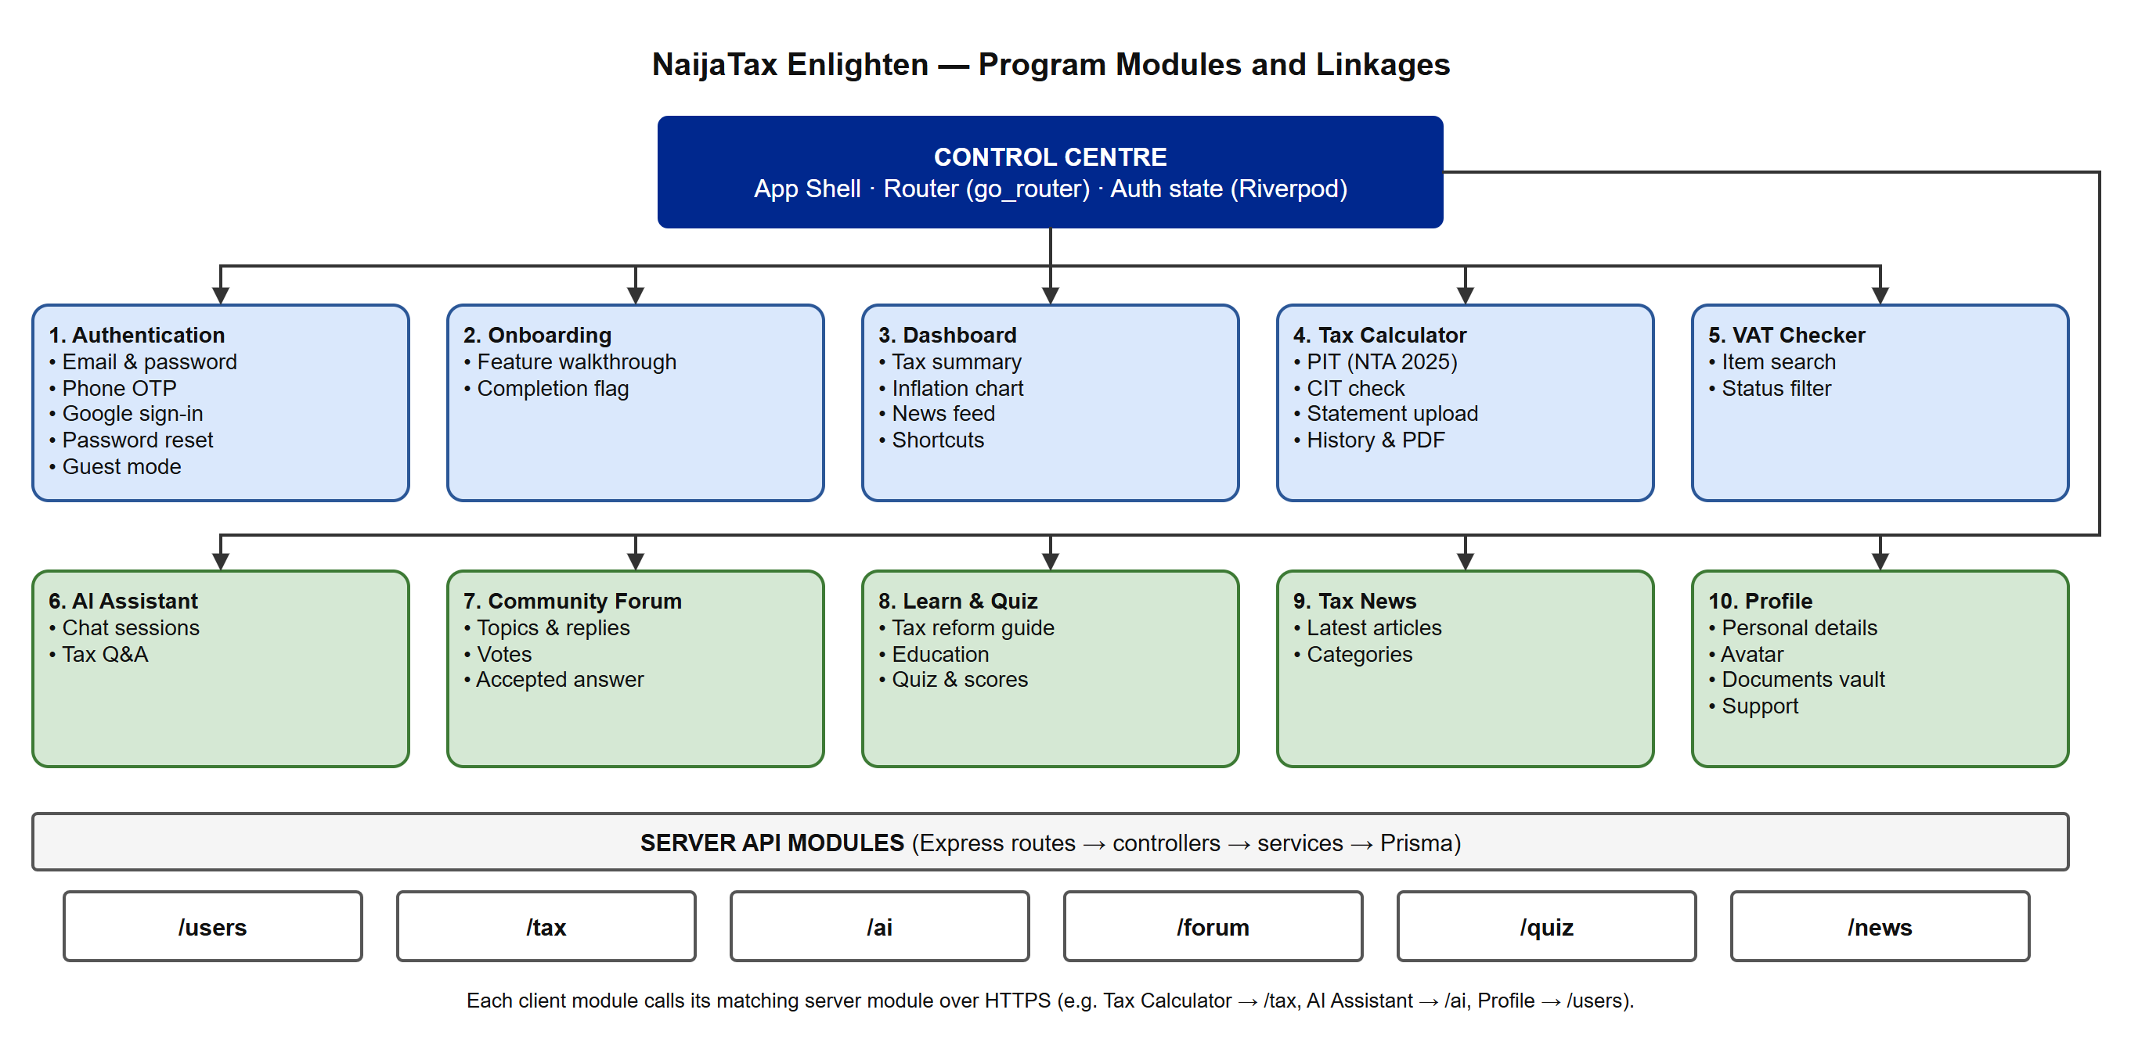
Figure 4.2: Program modules of NaijaTax Enlighten and their linkages
Table 4.4: Description of program modules
Module | Function
Authentication | Registers and signs in users by email/password, phone OTP or Google; supports password reset and guest access
Onboarding | Introduces the app's features once; completion is stored against the user account
Dashboard | Shows the latest tax summary, inflation chart, featured news and shortcuts
Tax Calculator | Computes personal income tax under NTA 2025, checks company income tax status, reads bank statements, keeps history and exports PDF reports
VAT Checker | Searches goods and services and shows whether each is standard-rated, zero-rated or exempt
AI Assistant | Answers tax questions in natural language and saves chat sessions
Community Forum | Lets users post topics, reply, vote and mark an accepted answer
Learn & Quiz | Explains the tax reform and tests knowledge with graded quizzes
Tax News | Collects tax news from Nigerian sources and displays it by category
Profile | Manages personal details, profile photo, documents vault and support

4.2.4 Input and Output Formats
Figure 4.3 shows the structure of what goes into the core tax assessment module and what it produces. Inputs are entered through form fields (amounts in naira) or extracted from an uploaded bank statement. The module validates them, applies the deductions and the NTA 2025 progressive bands, and returns a structured result that the app displays as figures, a band-by-band table, charts and a downloadable PDF report.
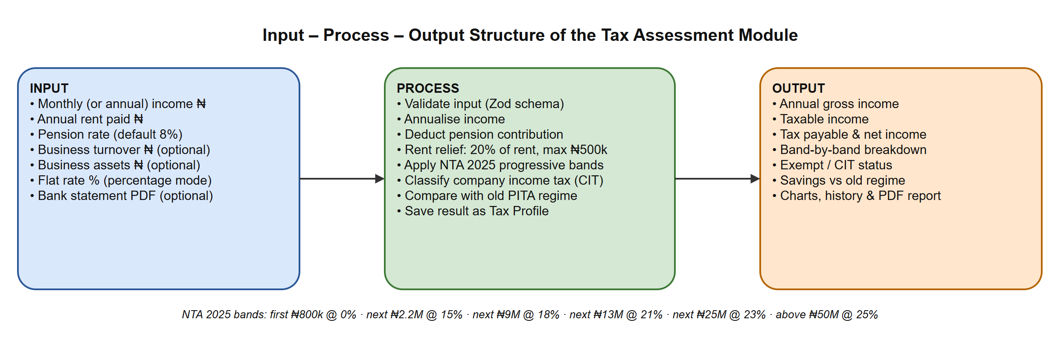
Figure 4.3: Input–process–output structure of the tax assessment module

4.2.5 Product and Information Flow
The "product" of NaijaTax Enlighten is information: tax computations, reports, AI guidance, VAT status, educational content and community answers, delivered free to individuals and small businesses through the Android app and the web app. Table 4.5 is an actor-by-actor matrix showing the information that flows between the parties involved in running the system, and the form in which it is produced.
Table 4.5: Information flow matrix (from row actor to column actor)
From \ To | System (API) | User | Administrator | External services
User | Income details, questions, forum posts, quiz answers | Forum replies and votes | — | Sign-in credentials (to Supabase Auth)
System (API) | — | Tax results, PDF reports, AI answers, scores, news | Usage data and synced news | Prompts (to AI provider), feed requests
Administrator | News sync requests, content updates | Featured articles | — | —
External services | Session tokens, AI answers, news articles | Google account chooser | — | —
Each tax result is produced once per calculation, stored as a tax profile record and can be exported any number of times as a PDF report. Chat sessions, forum posts and quiz scores are stored once and retrieved on demand.

4.2.6 Data Flow Diagrams
The data flow of the proposed solution is presented with the four standard DFD symbols: external entity (source or destination of data), process, data store and data flow. Figure 4.4 is the context diagram, which treats the whole system as one process. Figure 4.5 breaks it into its eight main processes and seven data stores.
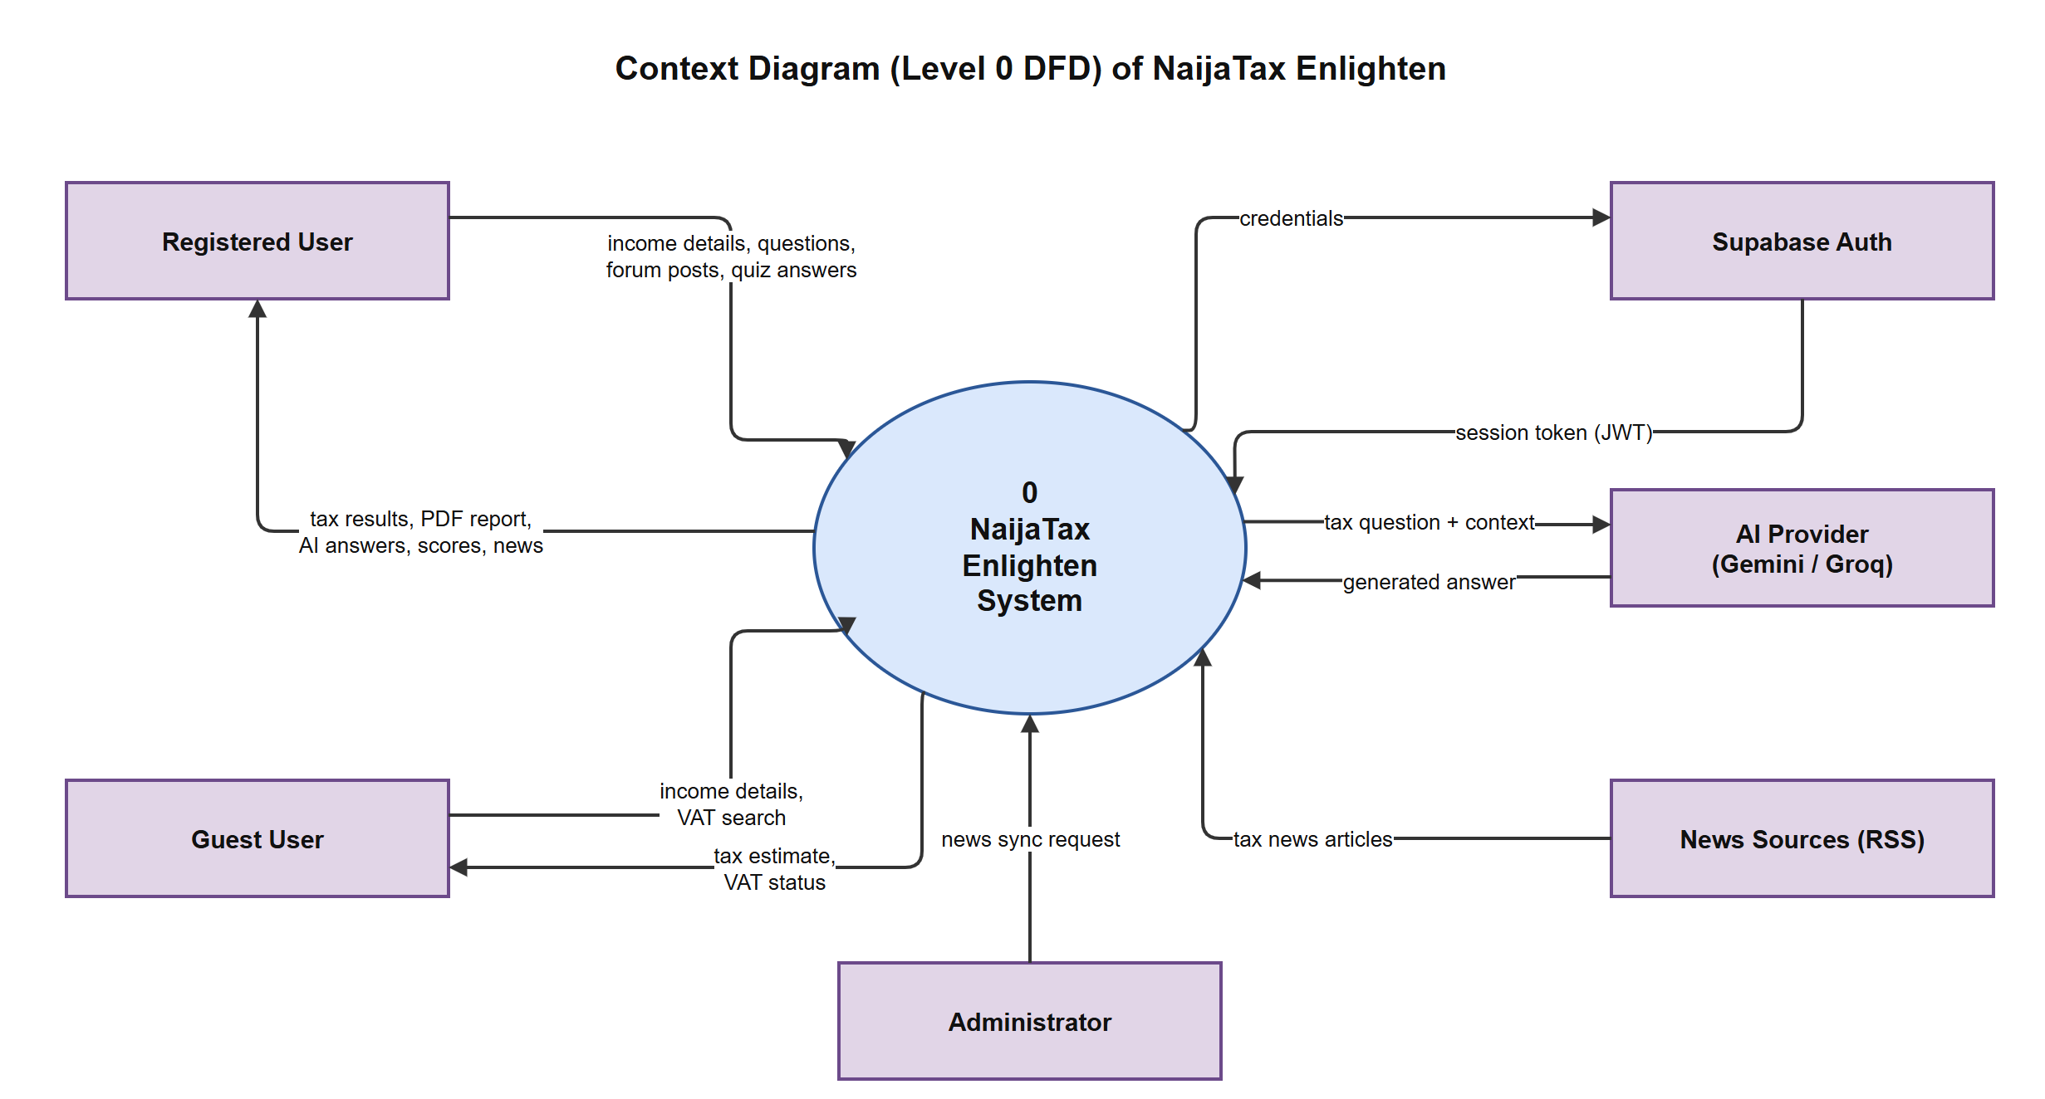
Figure 4.4: Context diagram (Level 0 DFD)
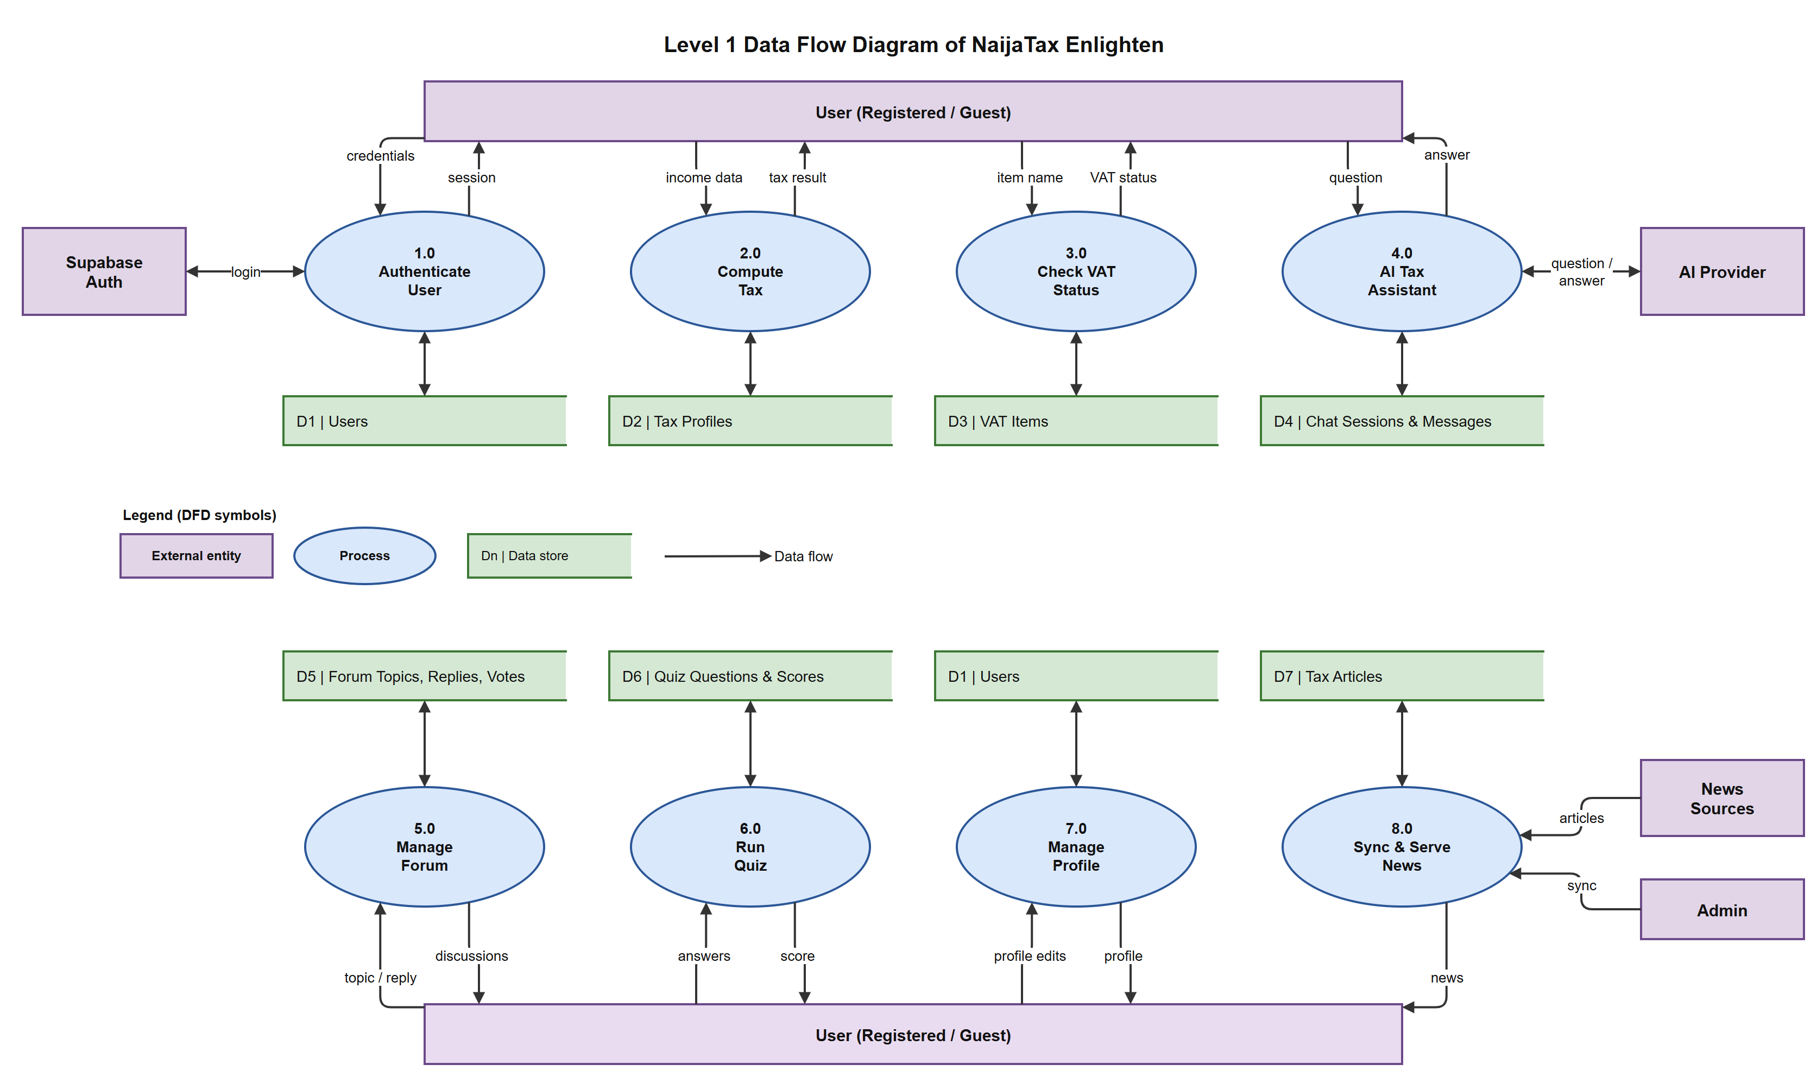
Figure 4.5: Level 1 data flow diagram

4.2.7 System Demonstration
Figures 4.6 to 4.8 show the deployed system. The web landing page (Figure 4.6) introduces the app and leads visitors to sign up, log in or continue as a guest. The login screen (Figure 4.7) offers email, phone and Google sign-in; on iOS and the web, Google always shows its account chooser so users can pick which account to use. After sign-in, new users pass through onboarding once and then reach the dashboard (Figure 4.8), which summarises the user's latest tax position, inflation trends and current tax news.
[ INSERT SCREENSHOT HERE ]
Capture: Web landing page on a desktop browser (full width), showing the hero section and the Sign In / Get Started buttons.
Figure 4.6: Web landing page of NaijaTax Enlighten

[ INSERT SCREENSHOT HERE ]  Capture: Login screen on a phone showing the email and password fields and the 'Continue with Google' button. |  | [ INSERT SCREENSHOT HERE ]  Capture: Dashboard on a phone after signing in, showing the tax summary card and news section.
Figure 4.7: Login screen |  | Figure 4.8: User dashboard

4.3 Software Testing
The system was tested at every stage of development so that errors were detected and removed immediately. Testing was carried out at four levels:
- Static analysis: the TypeScript compiler (tsc) and flutter analyze checked every change for type errors, unused code and unsafe patterns before it was run.
- Unit testing: the tax engine, which carries the highest risk of costly errors, was tested automatically with Vitest against hand-calculated values.
- Integration and system testing: the running app was used end-to-end against the local server and then against the deployed server, using sample data for each module.
- Continuous integration: GitHub Actions re-runs the type-check, unit tests and Flutter analysis on every push, so a change that breaks existing behaviour is rejected.

4.3.1 Unit Test Results
Table 4.6 summarises the automated tests for the tax engine. All 21 tests passed (Figure 4.9).
Table 4.6: Unit tests of the tax engine (Vitest)
Test group | What is verified | Tests | Result
Progressive bands | 0% on the first ₦800k; exact tax at each band boundary (₦3M, ₦12M, ₦25M, ₦50M); 25% only above ₦50M | 9 | Pass
Deductions | Pension and rent relief subtracted before banding; rent relief capped at ₦500k; monthly and annual input agree | 3 | Pass
Flat-rate mode | Selected flat rate applied; a 0% choice does not grant the statutory exemption | 2 | Pass
Savings comparison | Correct savings against the old regime; never negative | 2 | Pass
CIT classification | Small-business exemption limits; 20% and 30% rates for medium and large turnover | 5 | Pass
Total |  | 21 | Pass

[ INSERT SCREENSHOT HERE ]
Capture: Terminal running 'npm test' in the server folder, showing 'Test Files 1 passed' and 'Tests 21 passed'.
Figure 4.9: Automated unit test run showing all tests passing

4.3.2 System Testing with Sample Data
System tests were run through the user interface. In the main test, a user earning ₦450,000 per month who pays ₦1,200,000 rent per year and contributes 8% to a pension entered these figures into the tax calculator (Figure 4.10). The system produced the result in Figure 4.11, which matches the manual calculation in Table 4.7.
Table 4.7: Sample tax calculation: manual working versus system output
Item | Working | Amount
Annual gross income | ₦450,000 × 12 | ₦5,400,000
Pension deduction | 8% of ₦5,400,000 | ₦432,000
Rent relief | 20% of ₦1,200,000 (below the ₦500,000 cap) | ₦240,000
Taxable income | ₦5,400,000 − ₦432,000 − ₦240,000 | ₦4,728,000
Tax: first ₦800k | 0% | ₦0
Tax: next ₦2.2M | 15% of ₦2,200,000 | ₦330,000
Tax: remaining ₦1,728,000 | 18% of ₦1,728,000 | ₦311,040
Total tax payable | Sum of bands | ₦641,040
Net income | ₦5,400,000 − ₦432,000 − ₦641,040 | ₦4,326,960
Savings vs old regime | Computed by the system | ₦36,080

[ INSERT SCREENSHOT HERE ]  Capture: Tax calculator form filled with the sample data, before pressing Calculate.  Sample data: Monthly income ₦450,000; rent ₦1,200,000; pension 8% |  | [ INSERT SCREENSHOT HERE ]  Capture: Result screen showing tax payable, net income and the band-by-band breakdown.  Sample data: Tax ₦641,040; net ₦4,326,960
Figure 4.10: Tax calculator with sample input |  | Figure 4.11: Tax result generated by the system

Table 4.8 lists the other system test cases. Each was run on the Android app and the web app.
Table 4.8: System test cases
ID | Test case | Input | Expected result | Result
T1 | Email sign-up | New email and password | Account created; onboarding shown once, then dashboard | Pass
T2 | Google sign-in | Tap 'Continue with Google' | Google account chooser appears; user signed in | Pass
T3 | Returning user login | Existing account | Goes straight to dashboard with no onboarding flash | Pass
T4 | Guest restriction | Guest opens the forum post screen | Prompt to log in or sign up; landing page opens | Pass
T5 | Invalid input | Letters in the income field | Validation message; no request sent | Pass
T6 | VAT lookup | Search "rice" | Item shown with its VAT status | Pass
T7 | AI assistant | "Is my pension taxable?" | Relevant answer saved in a chat session | Pass
T8 | PDF report | Tap 'Download report' on a result | PDF with the breakdown is generated | Pass
T9 | Forum | Post a topic, then reply and vote | Topic, reply and vote counts appear | Pass
T10 | Quiz | Answer a 7-question quiz | Score shown and saved to history | Pass

[ INSERT SCREENSHOT HERE ]  Capture: The generated PDF tax report opened on the phone or in a PDF viewer. |  | [ INSERT SCREENSHOT HERE ]  Capture: AI assistant chat with the question 'Is my pension taxable?' and the answer shown.
Figure 4.12: PDF tax report generated from a result |  | Figure 4.13: AI tax assistant answering a question

4.4 Documentation

Data Dictionary
The data dictionary defines what each composite data item used by the system is made of. The relationships between the stored entities are shown in Figure 4.14, and the composition of each data item is given in Table 4.9 (PK = primary key, FK = foreign key).
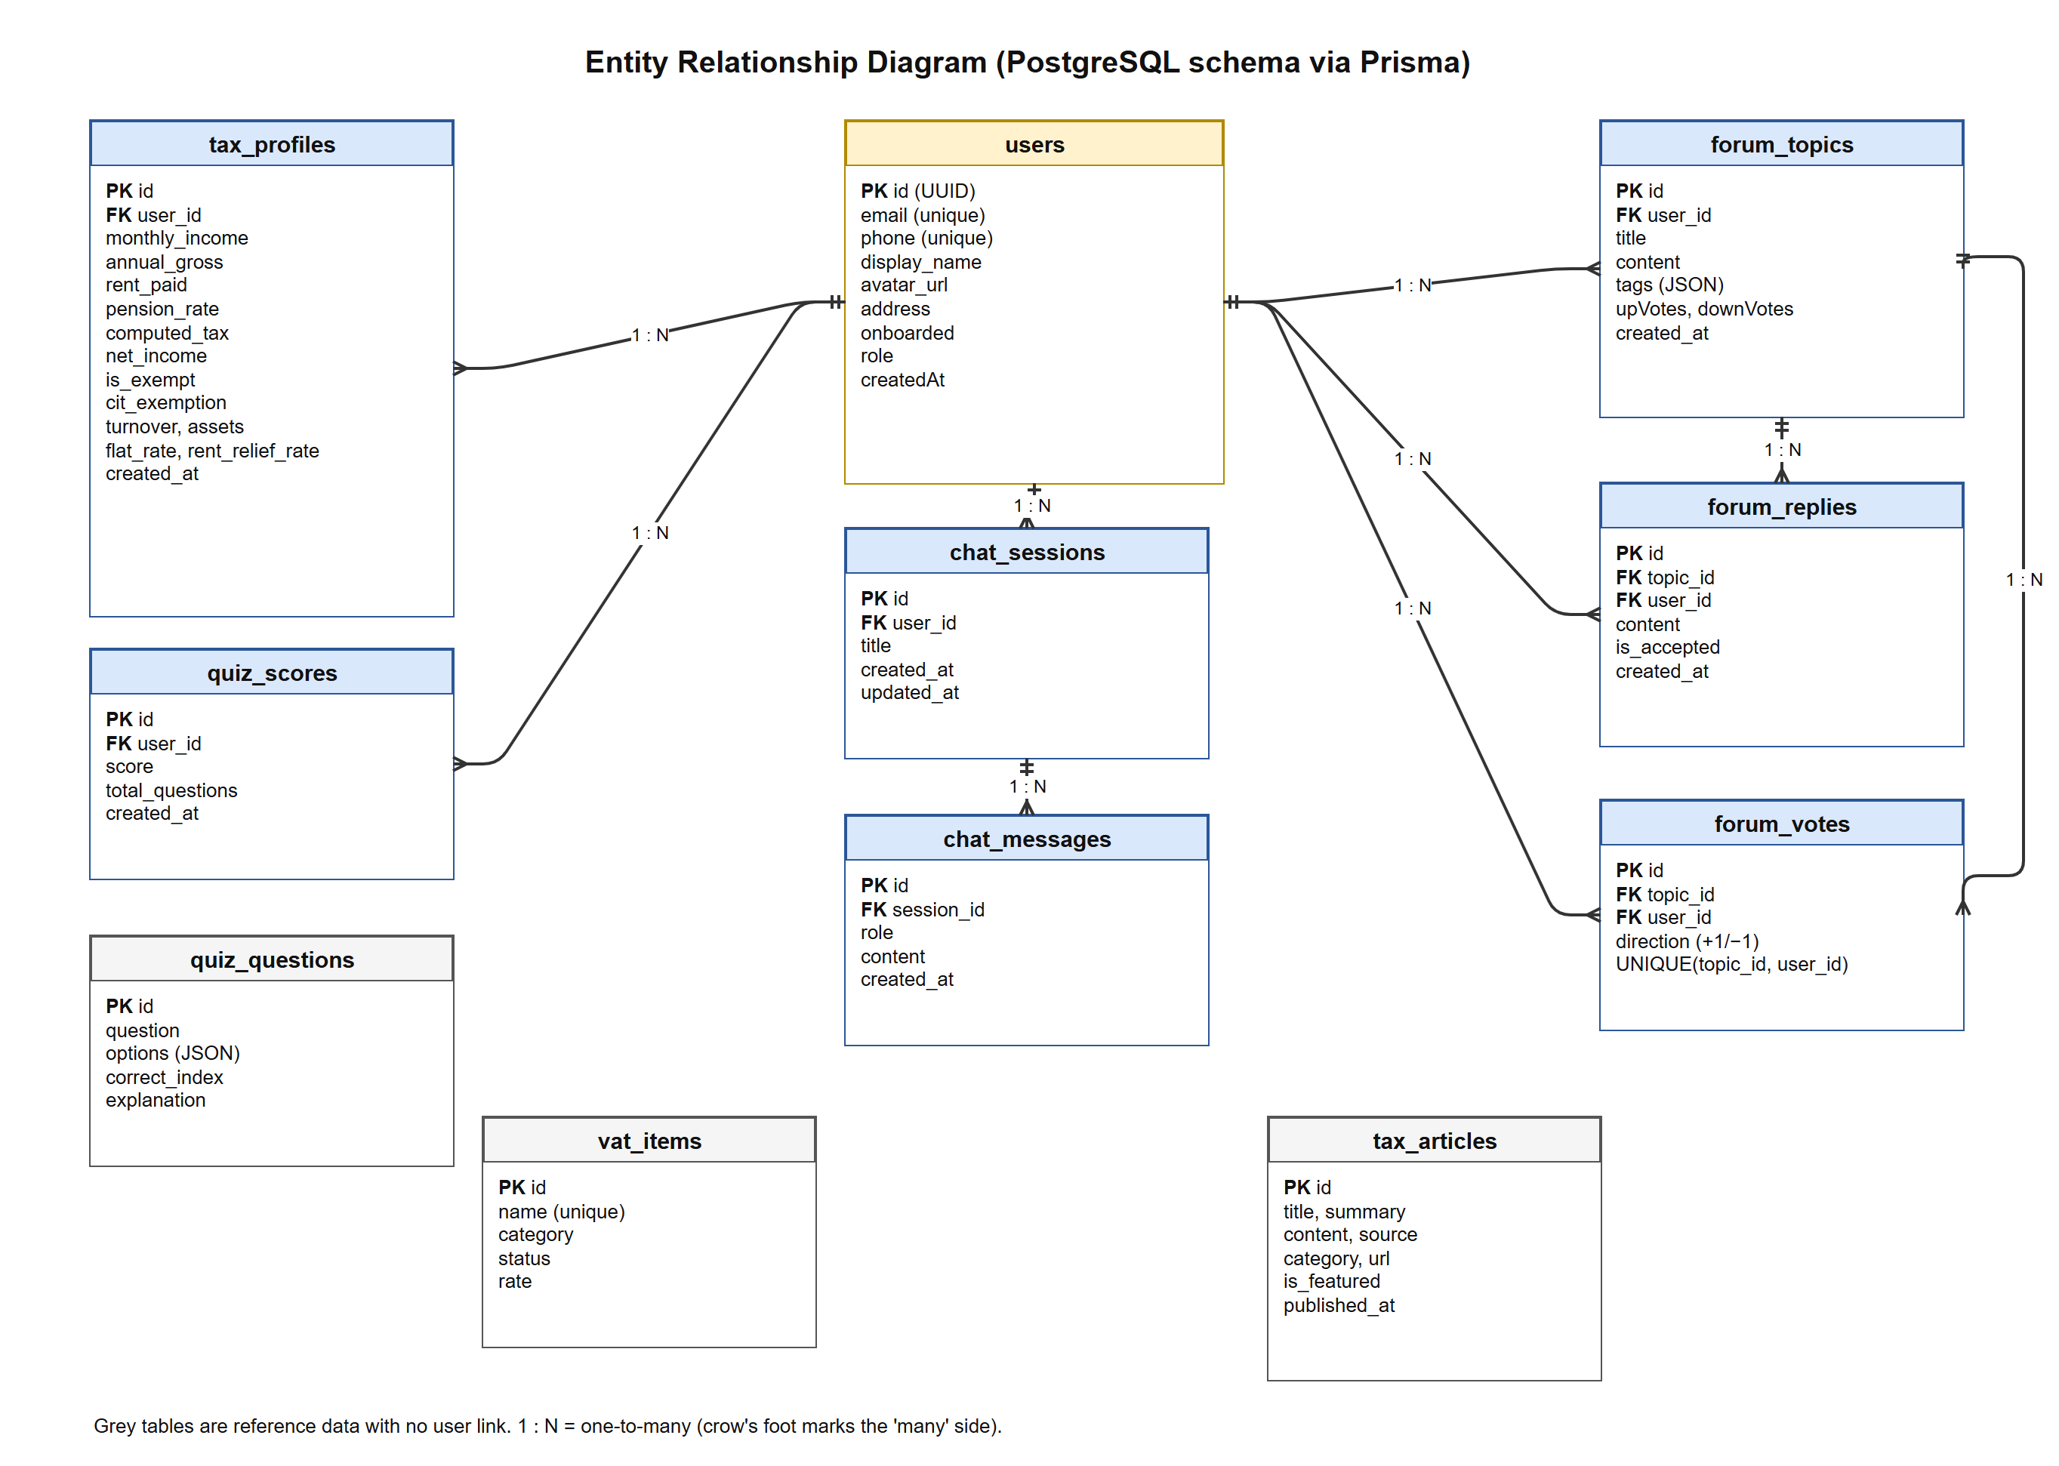
Figure 4.14: Entity relationship diagram of the database
Table 4.9: Data dictionary
Data item | Composition | Description
USER | User ID (PK) + Email + Phone + Display Name + Avatar URL + Address + Onboarded + Role + Date Created | A registered person; the ID matches the Supabase Auth account
TAX PROFILE | Profile ID (PK) + User ID (FK) + Monthly Income + Annual Gross + Rent Paid + Pension Rate + Computed Tax + Net Income + Is Exempt + CIT Status + Turnover + Assets + Flat Rate + Rent Relief Rate + Date | One saved tax calculation; amounts are DECIMAL(15,2) naira
VAT ITEM | Item ID (PK) + Name + Category + Status + Rate | Status is STANDARD, ZERO_RATED or EXEMPT
CHAT SESSION | Session ID (PK) + User ID (FK) + Title + Dates | A conversation with the AI assistant
CHAT MESSAGE | Message ID (PK) + Session ID (FK) + Role + Content + Date | Role is user or assistant
FORUM TOPIC | Topic ID (PK) + User ID (FK) + Title + Content + Tags + Up Votes + Down Votes + Dates | A community question or discussion
FORUM REPLY | Reply ID (PK) + Topic ID (FK) + User ID (FK) + Content + Is Accepted + Date | An answer to a topic
FORUM VOTE | Vote ID (PK) + Topic ID (FK) + User ID (FK) + Direction | +1 or −1; one vote per user per topic
QUIZ QUESTION | Question ID (PK) + Question + Options + Correct Index + Explanation | Options stored as a JSON list
QUIZ SCORE | Score ID (PK) + User ID (FK) + Score + Total Questions + Date | One completed quiz attempt
TAX ARTICLE | Article ID (PK) + Title + Summary + Content + Source + Category + URL + Is Featured + Published Date | A tax news item from an RSS source

4.4.1 User Manual
A. Installation
Android:
- Copy the file NaijaTax.apk to the phone, or download it from the link provided.
- Open the file. If prompted, allow installation from this source in Settings.
- Tap Install, then Open. The NaijaTax Enlighten icon appears on the home screen.
Web (any device): open the NaijaTax Enlighten web address in a browser. On iPhone, tap Share → Add to Home Screen to use it like an app.
Developer set-up (running from source):
- Install Flutter 3.44, Node.js 20 and Git, then clone the project repository.
- In the server folder, copy .env.example to .env and fill in the database URL, Supabase URL and Gemini API key; run npm install, npx prisma migrate deploy and npm run db:seed.
- Start the API with npm run dev (it listens on port 3000).
- In the client folder, create config.dev.json from config.example.json, run flutter pub get, then flutter run --dart-define-from-file=config.dev.json.
B. Using the application
- Sign up or log in with email, phone number or Google, or tap Continue as Guest to try the calculator and VAT checker without an account.
- Read through the short onboarding screens (shown once) to reach the dashboard.
- Open Calculator, enter your monthly income, annual rent and pension rate (and business turnover and assets if you run a business), then tap Calculate. Optionally upload a bank statement PDF to fill the form automatically.
- Review the tax payable, net income and band breakdown; tap Download report to save a PDF, or open History to see past calculations.
- Use VAT Items to check whether a product or service attracts VAT.
- Open AI Assistant to ask tax questions in plain language; previous chats are kept in the side menu.
- Use Community to ask questions or answer others, and Learn to read about the reform and take quizzes.
- Open Profile to edit personal details, change your photo, store documents or sign out.

4.4.2 Source Code Listing
The project is organised into two folders: client (the Flutter application: screens, providers, services and widgets) and server (the Express API: routes, controllers, services, authentication middleware and the Prisma schema). For the source code listing and sample outputs, see Appendices A and B respectively.

